

Educational Institute Management System
  - Comprehensive Advanced Programming Project Documentation
  - Prepared by:
  - Taimour Mushtaq
  - Abdur Rahman
  - Binyameen
  - M. Mateen Arshad

  - Submitted to:
  - Mr. Muhammad Aqib Rauf

Table of Contents

Table of Contents 1
1. Introduction 2
1.1 Purpose 3
2. Literature Review 3
2.1 Observations from Existing Systems 3
2.2 Common Shortcomings & Gaps in Prior Work 4
3. Problem Statement 4
4. Solution 5
4.1. Modules Included 6
4.1.1 Student Management 6
4.1.2 Teacher Management 6
4.1.3 Class Scheduling 6
4.1.4 Attendance Tracking 6
4.2 Additional Features 6
5. Methodology 6
5.1 Requirement Analysis 7
5.2 System Design 7
5.3 Database Development 7
5.4 Application Development 7
5.5 Authentication & Security 7
5.6 Testing 7
5.7 Deployment & Documentation 8
5.8 Tools and Technologies 8
6. Flow/ERD 9
6.1 Database Overview 11
6.1.2 Relationships Summary 11
6.1.3 User Authentication (Login System) 11
6.1.4 Database Features 12
7. Results 12
8. Conclusion 13
9. References 14

Introduction
The Educational Institute Management System is a desktop-based application designed to help school administrators manage essential academic operations more efficiently. This system simplifies the handling of student and teacher records, class schedules, and attendance tracking all within a single, user-friendly interface.
Built using .NET and SQL Server, the system aims to reduce manual paperwork and improve data accuracy by offering digital forms and automated processes. It is especially suitable for small to medium-sized schools that need a basic yet functional solution to organize their daily activities.
This project is ideal for academic learning, allowing students to practice database design, form development, and backend integration while solving real-world problems in education management.

1.1 Purpose
- Build a simple system to manage institutes operations digitally
- Help staff organize student and teacher records
- Automate class scheduling and attendance tracking
- Make data entry and reporting easier for administrators

Literature Review
Over time, many types of educational management systems (both open-source and commercial) have emerged. Broadly, they fall into these categories:
- Web / Cloud / Online-based systems: accessed over the internet, often with many modules, flexibility, and remote access.
- Desktop / Offline systems: installed locally, work without internet, simpler and suitable for small to medium institutions.
- Hybrid / Modular open-source systems: allow customization, sometimes mixing offline and online components.
Each of these categories has pros and cons depending on the size and resources of a school.

2.1 Observations from Existing Systems
- Web-based systems (SchoolTool, Fedena, RosarioSIS, ICTSchool) tend to be feature-rich and modular, often including extra modules like fees, transport, hostel, finance, etc.
- However, they require server infrastructure, internet, or hosting, and may be overkilled for small/medium schools needing only basic records, timetables, and attendance.
- Desktop-based systems exist (like the VB.NET + SQL Server one above), which suit offline use but often come with a broad feature set and heavy design.
- Many open-source systems assume some technical skill for setup and maintenance (e.g., web server / database management), which may be a barrier for small institutes with limited technical staff.

2.2 Common Shortcomings & Gaps in Prior Work
From the surveyed systems and from literature on school management software, common problems include:
- Over-complexity for small institutes: Many systems offer many modules (fees, hostel, transport, bus, payroll, etc.) which small schools may not need to make UI cluttered and overwhelming.
- Dependency on server / internet: Web-based systems require hosting and stable internet, which may not always be available (especially in small towns or resource-constrained institutes).
- Scalability vs. simplicity tradeoff: Some desktop systems with simple design use less scalable databases (e.g. MS Access), limiting future expansion.
- Poor usability / steep learning curve: Complex systems or poorly designed UI require training; staff may find it difficult to adopt.
- Lack of essential yet simple features: Some systems may ignore basic but critical requirements like role-based login, password recovery, duplicate-checks for attendance, or straightforward timetable scheduling.
- Maintenance overhead: Open-source or self-hosted systems may need technical staff for upkeep, backups, updates.

Problem Statement
Many existing student management systems are either too complex, expensive, or lack essential features needed by small and medium-sized educational institutes. Schools often struggle because:
- No proper and reliable login systems (e.g. for each user a separate login and authentication is missing).
- No full control to Admin as the admin panel is missing or exists with limited controls and resources.
- Duplication in attendance marking (e.g., no check for a student mark present twice or marked present and absent at a same time).
- Most solutions require internet connectivity, external servers, or high maintenance
- No password retrieval system which may cause loss of important data and information.
- Built in local data bases (MS Excel, MS Access, My Sql etc) which leads to limited scalability and unable to handle large data.
- Interfaces are difficult for non-technical staff to use
- Basic modules like attendance or timetable management are missing or poorly implemented
As a result, institutes still rely on manual paperwork, leading to errors, poor data organization, and time-consuming administrative tasks.

Solution
To overcome these limitations, this project introduces a simple, affordable, and fully offline Desktop-Based Educational Institute Management System designed specifically for smaller institutes.
Our system offers:
- Secure login pages with backend checks for each role (i.e., Admin, Student, Teacher).
- Full fledge admin panel with all necessary resources, privileges and control over the entire system.
- Necessary checks at frontend level (runtime on C#) as well as at backend level (SQL Server database) to avoid duplications and data redundancy to ensure transparency.
- Offline operation, no server or internet required
- Password retrieval system to avoid the loss of data and system recovery.
- All essential modules in one place: Students, Teachers, Timetable, and Attendance.
- Automated class schedules.
- Accurate and reliable SQL Server database for secure record management and increased scalability.
- A user-friendly interface that even non-technical staff can operate
- Lightweight application built in .NET: fast, stable, and easy to deploy
- Optional role-based login for Admin, Teacher, and Student access
This system removes unnecessary complexity while providing exactly the features schools need, resulting in better organization, fewer errors, and improved efficiency.

4.1. Modules Included

4.1.1 Student Management
- Add, edit, and view student details
- Organize students by class or section

4.1.2 Teacher Management
- Maintain teacher profiles
- Assign subjects and classes to teachers

4.1.3 Class Scheduling
- Create timetables for each class
- Assign subjects and teachers to time slots

4.1.4 Attendance Tracking
- Mark daily attendance for students
- View attendance reports by class or date

4.2 Additional Features
- Timetable Management
- Add and update student and teacher records
- Assign teachers to subjects and classes
- Create and manage class timetables
- Mark student attendance
- Search students or teachers by name or class
- Checks at UI and DB end to prevent double marks for any student
- Optional: Admin login for secure access

5. Methodology

5.1 Requirement Analysis
- Understand institute needs (students, teachers, schedules, attendance)
- Identify necessary modules: Student, Teacher, Timetable, Attendance, Login
- Define objectives: reduce paperwork, improve accuracy, simplify management

5.2 System Design
- ERD design for relational SQL database
- Define primary and foreign keys for module relationships
- Wireframe design for Windows Forms (UI screens)
- Plan workflow for each operation (add, edit, search, attendance marking)

5.3 Database Development
- Create SQL Server tables for: Students, Teachers, Classes, Attendance, Login, etc.
- Implement constraints for data validation (no duplicates)
- Add stored procedures (optional) for insert/update operations

5.4 Application Development
- Using C#, .NET Windows Forms, ADO.NET:
- Develop forms for each module
- Implement CRUD operations
- Link UI with database through SQL queries
- Build attendance logic with duplicate-entry prevention
- Add class scheduling logic (assign teacher + subject + timeslot)

5.5 Authentication & Security
- Create login system for Admin, Teacher, and Student roles
- Restrict access based on assigned permissions
- Validate user credentials from SQL database

5.6 Testing
- Test database CRUD operations
- Validate timetable creation
- Ensure attendance cannot be marked twice
- Test login access for all roles
- Fix UI and backend integration bugs

5.7 Deployment & Documentation
- Finalize the executable (.exe) for Windows
- Provide user guide
- Create project documentation and PPT for submission

5.8 Tools and Technologies
- .NET (Windows Forms)
- SQL Server
- C# programming language
- Visual Studio 2022
- ADO.NET for database access
- Microsoft Office
- Draw.io

Fig 5.0: SDLC for Institute Management System

6. Flow/ERD

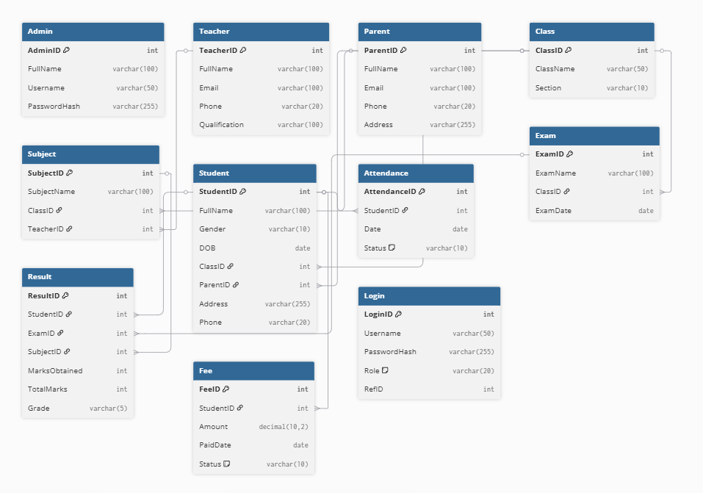

6.1 Database Overview
6.1.1 General Structure
- The system uses a relational database built in SQL Server.
- Each module (Student, Teacher, Class Schedule, Attendance) is backed by a separate table.
- Tables are connected using primary and foreign keys to maintain relationships.

6.1.2 Relationships Summary
- One Class has many Students and Subjects.
- One Teacher teaches multiple Subjects and Classes.
- One Student can have many Attendance, Fee, Assignment, and Result records.
- Each Exam generates multiple Results.
- Each Login entry links to one user role (Admin, Teacher, Student).

6.1.3 User Authentication (Login System)
- Separate login portals for:
- Admin: Full system access.
- Teacher: Access to assigned classes, attendance, and results.
- Student: View personal data, attendance, exams, and results.

6.1.4 Database Features
- Data validation to prevent duplicate entries
- Search queries to find students or teachers quickly
- Joins to combine data across modules (e.g., show which teacher teaches which class)
- Stored procedures (optional) for inserting and updating records efficiently

7. Results
Previous Work | Current Work
- Used MySQL / MS Access with limited scalability | - Uses SQL Server with strong relationships and future scalability
- Simple outdated UI | - Clean, user-friendly, modern Windows Forms UI
- No password recovery features | - Secure Password Retrieval system
- No secure login or single-user access | - Role-based Login (Admin, Teacher, Student)
- No attendance system or prone to duplicate marking | - Attendance system with duplicate-entry prevention

Fig 7.1. Graph of Results Comparison

8. Conclusion
The Educational Institute Management System offers a practical solution for organizing and managing key school operations such as student records, teacher assignments, class schedules, and attendance tracking. By digitizing these processes, the system reduces manual workload, improves data accuracy, and enhances overall efficiency for school staff.
This project is designed to be simple yet functional, making it ideal for academic learning and real-world applications in small to medium-sized schools. Using .NET and SQL Server, the system provides a strong foundation for understanding database relationships, form-based interfaces, and backend integration.
With its modular structure and beginner-friendly features, the Educational Institute Management System serves as a valuable opportunity for students to apply programming skills, explore system design, and deliver a complete working application with real educational impact.

9. References
9.1. Student Management System developed by Students of "Jaypee University of Information Technology"
9.2. Student Management System by "KRISHNA’S PRAGATI INSTITUTE OF TECHNOLOGY"
9.3. Student Management System Project Report | PDF | System | Design
9.4. MashiAma/Student-Management-System: Implementation of Student Management System
9.5. https://www.eraser.io
9.6. https://www.drawio.com
9.7. https://learn.microsoft.com/en-us/dotnet/framework
9.8. https://How to Make a Word Document Look Professional in 8 Steps
9.9. Guna UI WinForms | Guna Framework - .NET UI/UX Controls and Components for Developers of Desktop, Reporting, Data Visualization
9.10. https://SQL Server Downloads | Microsoft
9.11. C# - a modern, open-source programming language | .NET

